

IALA S-201
Product Specification

Edition 1.1.0 – September 2022

IALA AtoN Information Product Specification

Document Revisions
Revisions to the IALA Document are to be noted in the table prior to the issue of a revised document.
Date | Page / Section Revised | Requirement for Revision
03/03/2016 | Various | See comments table 20160127
09/03/2016 | Section 7.6 Geometry | Remove square brackets from S-201
09/03/2016 | Section 8.2 Data Compliance | S-58 replaces Annex H for consistency
09/03/2016 | Section 12.1 Encoding | Indicate conformity with S-100
09/03/2016 | Section 11 Portrayal | Removed (not required)
04/07/2016 | Various | FTA proposals
21/09/2016 | Various | Reviewed at ENAV 19
26/11/2016 | Various | Updated various sections and figures following data model update
31/01/2017 | Various | Changed precision of lat/long, added units, various editorial changes
15/08/2017 | Various | Partial implementation of TG1 July 2017 report. Aligned metadata and dataset identification with S-100 Edition 3.0.0, included AIS AtoNs and base station (Radio Station), minor clarifications for file names and support files.
31/09/2019 | Various | Updating specification to S-100 v4.0.0 and various edits following review at IALA ARM9.
19/03/2022 | Various | Improved application schema, updating specification to S-100 Ed.5.0.0
02/09/2022 | Various | Updated various sections and figures following data model update
27/10/2022 | Various | Various edits following review at IALA ARM16

Table of Contents
Contents
1 Overview 7
1.1 Introduction 7
1.2 References 7
1.2.1 Normative references 7
1.2.2 Informative references 7
1.3 Terms, definitions and abbreviations 7
1.3.1 Terms and definitions 7
1.3.2 Acronyms 7
1.4 Product specification metadata 8
1.4.1 IALA Product Specification Maintenance 8
2 Specification Scope 10
3 Data Product Identification 10
4 Data Content and structure 11
4.1 Introduction 11
4.2 Application Schema 11
4.3 Meta features application schema 25
4.4 Feature Catalogue 26
4.5 Feature Types and Feature Instances 27
4.6 Dataset 27
4.7 Dataset rules 27
4.8 Geometry 27
5 Coordinate Reference Systems (CRS) 29
5.1 Introduction 29
5.2 Horizontal Geodetic Datum 29
5.3 Vertical Datum 29
5.4 Units of Measure 29
6 Data Quality 29
6.1 Introduction 29
6.2 Data Compliance and Integrity 29
6.3 Positional accuracy 30
6.4 Lineage 30
7 Data Capture and Classification 30
8 Data Maintenance 30
8.1 Introduction 30
8.2 Maintenance and Update Frequency 30
9 Portrayal 31
10 Data Product format (encoding) 31
10.1 Introduction 31
10.2 Encoding of Latitude and Longitude 31
10.3 Encoding of coordinates as decimals 31
10.4 Numeric Attribute Encoding 31
10.5 Text Attribute Values 32
10.6 Mandatory Attribute Values 32
10.7 Unknown Attribute Values 32
10.8 Structure of dataset files 32
10.9 Object identifiers 33
10.10 Dataset validation 33
10.11 Detailed documentation of schema 33
10.12 Data coverage 33
10.13 Data overlap 33
10.14 Data quality 33
10.15 Data extent 33
11 Data Product Delivery 34
11.1 Exchange set 34
11.2 Datasets 36
11.3 Dataset size 36
11.4 Dataset file naming 36
11.5 Cancellations 36
11.6 Support Files 37
11.7 Support File Naming 37
11.8 Support file management 37
11.9 Exchange Catalogue 38
12 Metadata 38
12.1 Introduction 38
12.2 Metadata classes 40
12.2.1 S100_ExchangeCatalogue 42
12.2.2 S100_DatasetDiscoveryMetadata 43
12.2.3 S100_ProductSpecification 51
12.2.4 S100_SupportFileDiscoveryMetadata 52
12.2.5 S100_CatalogueDiscoveryMetadata 55

Overview

Introduction
The Aids to Navigation (AtoN) Information Product Specification provides a common structure for the exchange of information about AtoNs including metadata like maintenance schedules, equipment type such as battery and bulb types. This includes buoys, beacons, racons, lights, sound signals and AIS. The product contains the positions, properties, operational status and general comments related to an AtoN.
The Product Specification can be used to exchange AtoN information in a consistent form between Lighthouse Authorities, Hydrographic Offices and other organizations to include commercial and professional agencies. S-201 is not intended to be for navigation systems like ECDIS, and therefore is not constrained by ECDIS requirements. This means the S-201 can include additional information to inform about AtoN services that would not be appropriate in a navigation system such as AtoN fixing method, moorings and power source.

References

Normative references
IHO S-100 IHO Universal Hydrographic Data Model, Edition 5.0.0, October 2022
ISO 8601:2004 Data elements and interchange formats _ Information interchange _ Representation of dates and times
ISO/TS 19103:2005 Geographic information - Conceptual schema language
ISO 19111:2003 Geographic information - Spatial referencing by coordinates
ISO 19115-1:2014 Geographic information – Metadata (Tech Corr. 1, 2006)
ISO 19131:2007 Geographic information - Data product specifications
ISO/IEC 19505-1:2012, Information technology — Open Distributed Processing - Unified Modelling Language Version 2.4.1
ISO 3166-1 Country Codes

Informative references
ISO, 2006. ISO 19109 Geographic Information - Rules for Application Schema.
ISO, 2007. ISO 19135 Geographic Information – Procedures for Item Registration.
ISO, 2009. ISO 19136 Geographic Information - Geography Markup Language (GML).
IMO, 2008. Safety of Navigation Circular SN/Circ.243
IALA, 2012. Guideline 1088 on an Introduction to Preparing S-100 Product Specifications

Terms, definitions and abbreviations

Terms and definitions
Terms and definitions have been taken from the normative references cited in clause 1.2.1.

Acronyms
ASCII American Standard Code for Information Interchange
AtoN Aid to navigation
CRS Coordinate Reference System
ECDIS Electronic Chart Display and Information System
EPSG European Petroleum Survey Group
ENC Electronic Navigational Chart
GML Geography Markup Language
HTML Hypertext Markup Language
IALA International Association of Marine Aids to Navigation and Lighthouse
Authorities
IHO International Hydrographic Organization
IMO International Maritime Organization
ISO International Organization for Standardization
TIFF Tag Image File Format
XML Extensible Markup Language
XSLT eXtensible Stylesheet Language

Product specification metadata

Title | Aids to Navigation Product Specification
Version  Identifier | 1.1.0  S-201
S-100 version | 5.0.0
Date | 02 September 2022
Language | English
Classification: | 001 - unclassified
Contact: | IALA-AISM  10, rue des Gaudines  78100 Saint Germain en Laye, France  Telephone: +33 1 34 51 70 01 Fax: +33 1 34 51 82 05
URL: | www.iala-aism.org
Maintenance: | The product specification is maintained by IALA-AISM and amendments are performed on a needs base, up to maximum one new release per calendar year.

IALA Product Specification Maintenance
This section details the process of maintaining this document.

Introduction
Changes to this product specification will be released by IALA-AISM as a new edition, revision, or clarification.

New Edition
New editions of this product specification introduce significant changes. New editions enable new concepts, such as the ability to support new functions or applications, or the introduction of new constructs or data types.

Revisions
Revisions are defined as substantive semantic changes to a product specification. Typically, revisions will change a product specification to correct factual errors; introduce necessary changes that have become evident as a result of practical experience or changing circumstances. A revision must not be classified as a clarification. Revisions could have an impact on either existing users or future users of a product specification. All cumulative clarifications must be included with the release of approved corrections.
Changes in a revision are minor and ensure backward compatibility with the previous versions within the same edition. Newer revisions, for example, introduce new features and attributes. Within the same edition, a data product of one version could always be processed with a later version of the feature and portrayal catalogues.

Clarification
Clarifications are non-substantive changes to this product specification. Typically, clarifications: remove ambiguity; correct grammatical and spelling errors; amend or update cross references; insert improved graphics, spelling, punctuation and grammar. A clarification must not cause any substantive semantic change to a product specification.
Changes in a clarification are minor and ensure backward compatibility with the previous versions within the same edition. Within the same edition, a data product of one clarification version could always be processed with a later version of the feature and portrayal catalogues, and a portrayal catalogue can always rely on earlier versions of the feature catalogues.

Version Numbers
The associated version control numbering to identify changes (n) to this product specification will be as follows:
New editions denoted as n.0.0
Revisions denoted as n.n.0
Clarifications denoted as n.n.n

Specification Scope
This product specification describes one data product and therefore requires only one scope which is described below:

Scope ID: Aids to Navigation Information datasets.

Hierarchical level: MD_ScopeCode - 005

Hierarchical level name: dataset.

Level description: information applies to the dataset

Extent: EX_Extent.description: Global coverage of maritime areas

Data Product Identification
This clause describes how to identify data sets that conform to the specification. A dataset that conforms to this Product Specification may be identified by its discovery metadata as defined in clause 13 of this specification. The information identifying the data product may include the following items from S-100 5.0.0 clause 11-6 (adapted from ISO 19115-1).

Title | Aids to Navigation Information
Alternate Title | AtoN
Abstract | An Aids to Navigation Information is a vector dataset containing all relevant information regarding the aids to navigation within a defined geographical area.
Topic Category | Environment, Oceans, Structure and Transportation
Geographic Description | CharacterString
Spatial Extent | Global
Description | Aids to navigation information, such as characteristics of the AtoN, its location and maintenance procedures that apply
Spatial Resolution | All scales
Purpose | Aids to Navigation Information datasets are produced to allow the producer to exchange AtoN information with interested stakeholders.
Language | English
Spatial Representation Type | Vector
Point of Contact | IALA-AISM
Use Limitation

Data Content and structure

Introduction
An AtoN Information dataset is a feature-based product. The following sub-sections contain the product application schema expressed in UML and an associated feature catalogue. The feature catalogue provides a full description of each feature type including its attributes and attribute values in the data product.

Application Schema
The application schema conforms to the modelling conventions of UML as constrained in S-100 Part 1, and conforms to the General Feature Model described in Part 3.
An overview of the application schema is provided in Figure 1. Figures 2 - 7 provide details for feature types and their relationships. The allowed values for enumeration attributes are depicted in Figures 8 - 11. In conformance to S-57 and S-101, aids to navigation are described by combinations of structure and equipment features.
- The feature type AidsToNavigation is an abstract type from which the geographic feature types for aids to navigation are ultimately derived.
- StructureObject and Equipment are abstract types which collect the attributes and relationships common to structure and equipment features respectively. The relationship that exists between them is between structure and equipment features in the combining of structure and equipment object(s) to make up an individual aid to navigation.
- GenericBeacon and GenericBuoy are abstract types which collect attributes common to multiple types of beacon and buoy features respectively.
- Links to the geographic features for individual AtoNs constituting the collection object are modelled by feature associations (the “Aggregations” and “Associations” links between Aggregation and Association classes and the common supertype for geographic AtoN features (AidsToNavigation). The type of the collection feature is indicated by the attribute categoryOfAggregation which can take the allowed values listed in the codelists of the same names.
- Structure-equipment associations are modelled by the association labelled StructureEquipment, between classes Structure and Equipment in Figure 1.
- Features participating in the same range system are indicated by the association labelled RangeSystem, between feature classes NavigationLine and RecommendedTrack.
- The model supports three types of AIS features like physical (real), virtual and synthetic. The broadcasting station for virtual AIS is encoded as RadioStation, and may be associated with the virtual AIS it broadcasts by an association labelled VirtualAIS. AIS related items are shown in Figure 4.
- Only RadioStation that are AIS base stations can be included.
- The structure features are Lighthouse, Landmark, Pile, LightFloat, OffShorePlatform, LightVessel, and Silo/Tank features as well as buoys and beacons of different kinds. The detailed models of structure features are depicted in Figure 2.
- The equipment objects are Daymark, Fog Signal, Radar Reflector, Light, Retroreflector, Topmark, Radar Transponder Beacon, Environmental Observation Equipment, Physical AIS Aid to Navigation, and Radio Station. Daymark is allowed to act as either a structure or equipment feature in practice but this cannot at present be modelled in the application schema since S-100 discourages multiple inheritance. The detailed model of equipment objects is depicted in Figure 3.
- The feature classes Navigation Line and Recommended Track are neither structure nor equipment objects, and are depicted in complete detail in Figure 1. Documentation tables for the application schema are in Annex F.
- PowerSource inherited from the Equipment includes information about the type (battery, generator, solar panel, electronical service), status, and manufacturer of the power source
- MooringWarpingFacility and BuoyEmergencyWreckMarking are included to support purposes of mooring and emergency wreck buoy
- CounterWeight, MooringShackle, Bridle, Swivel, CableSubmarine, and SinkerAnchor are defined to define AtoN fixing method, moorings.

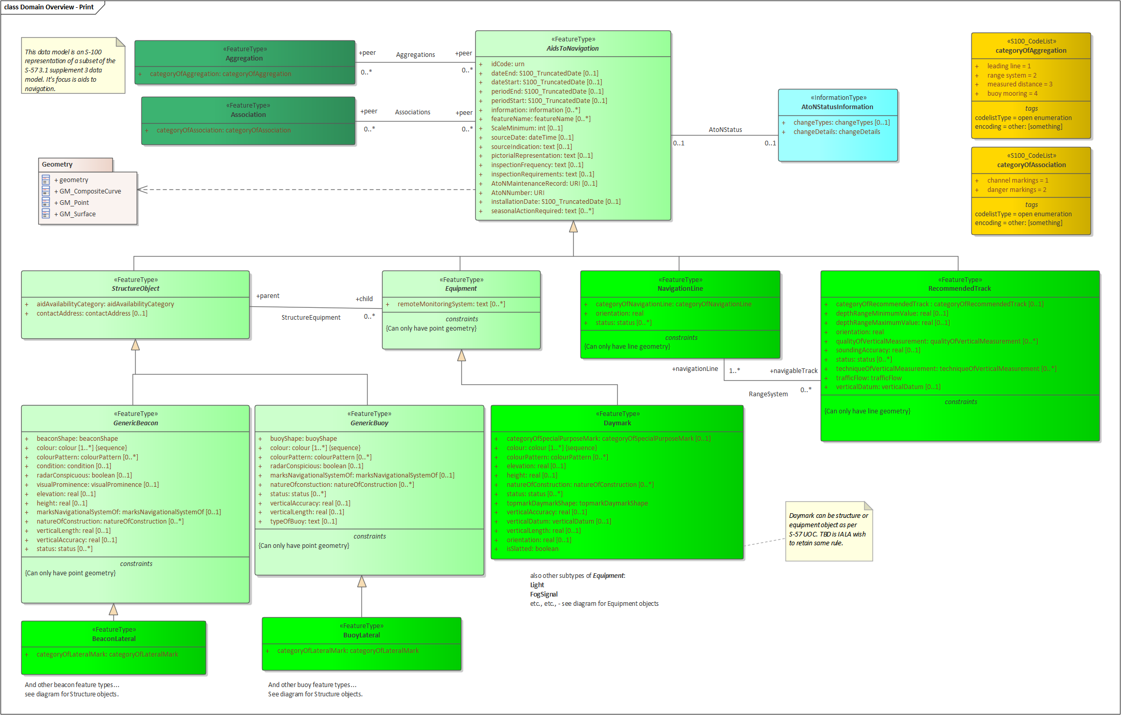
Figure 1. Overview of Application Schema
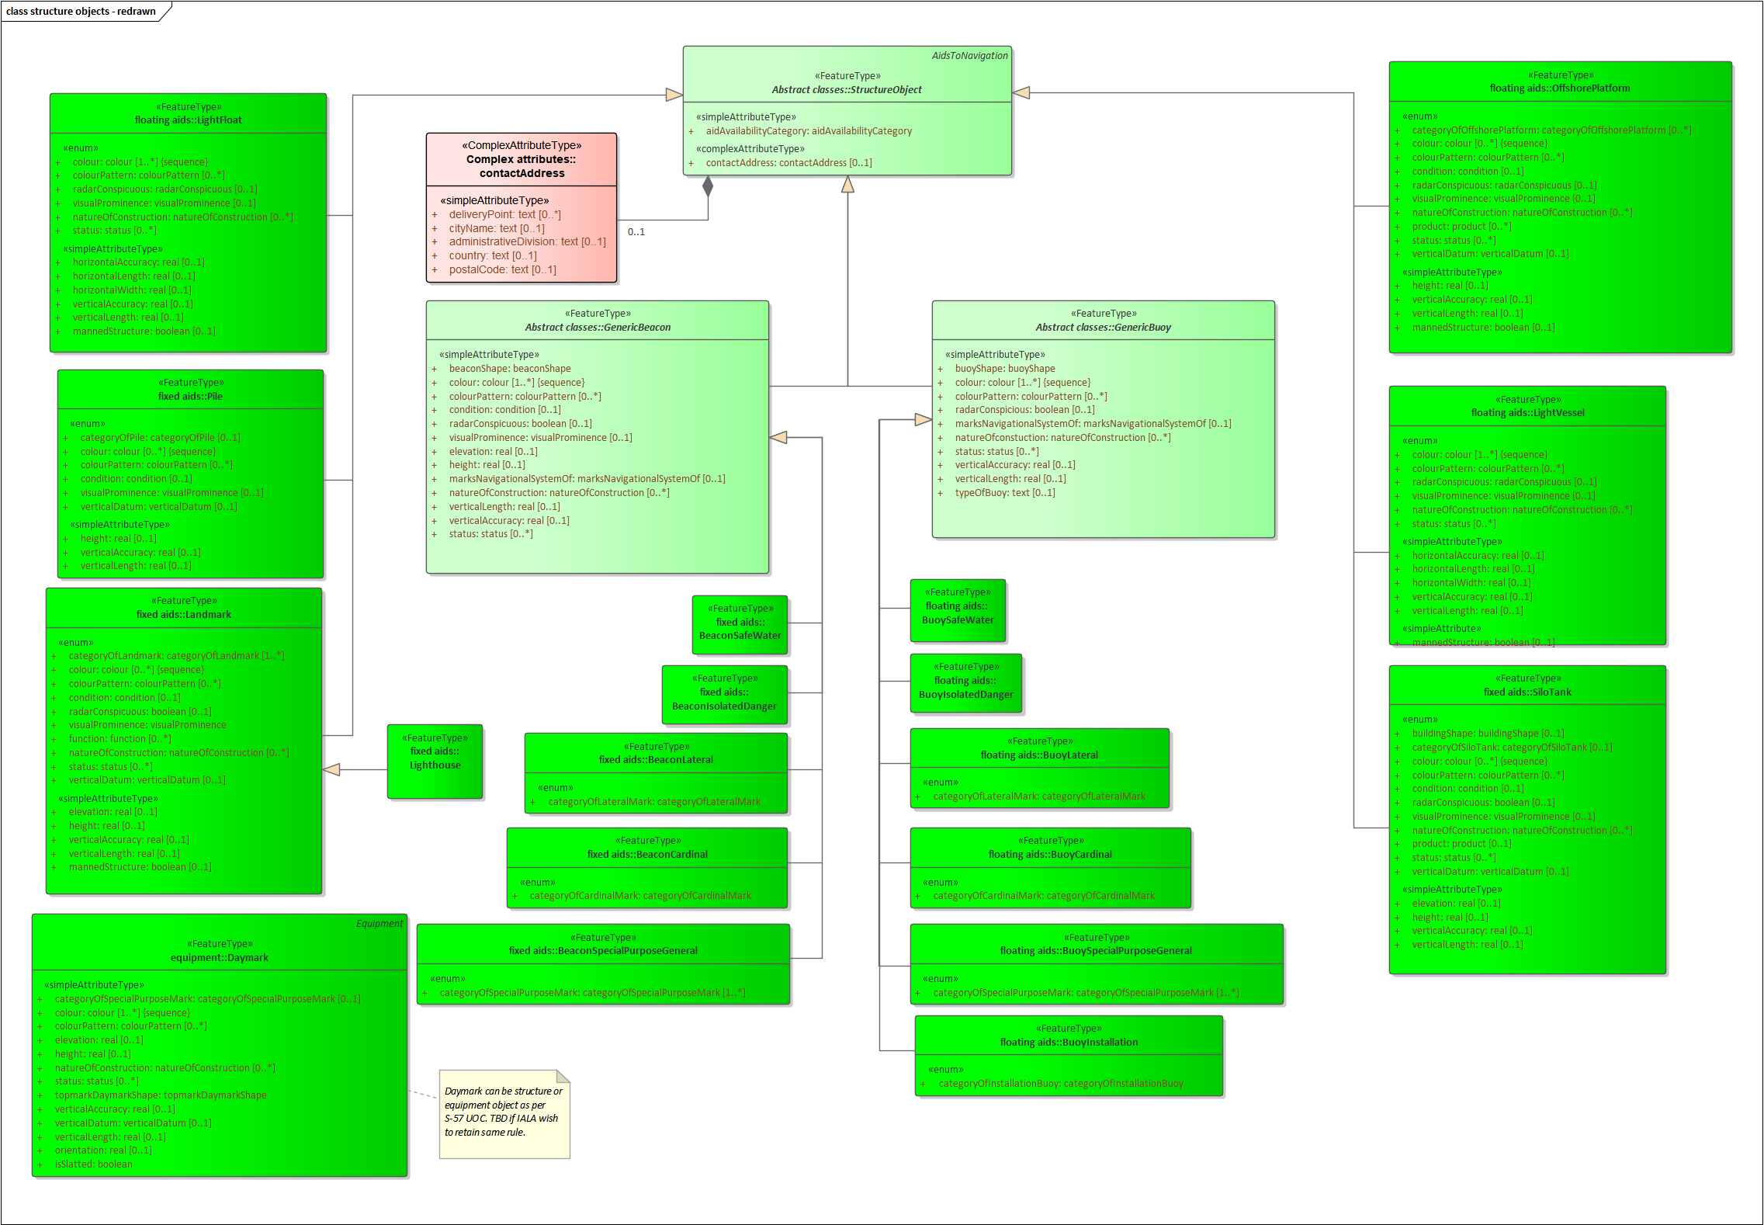
Figure 2. Structure Feature types
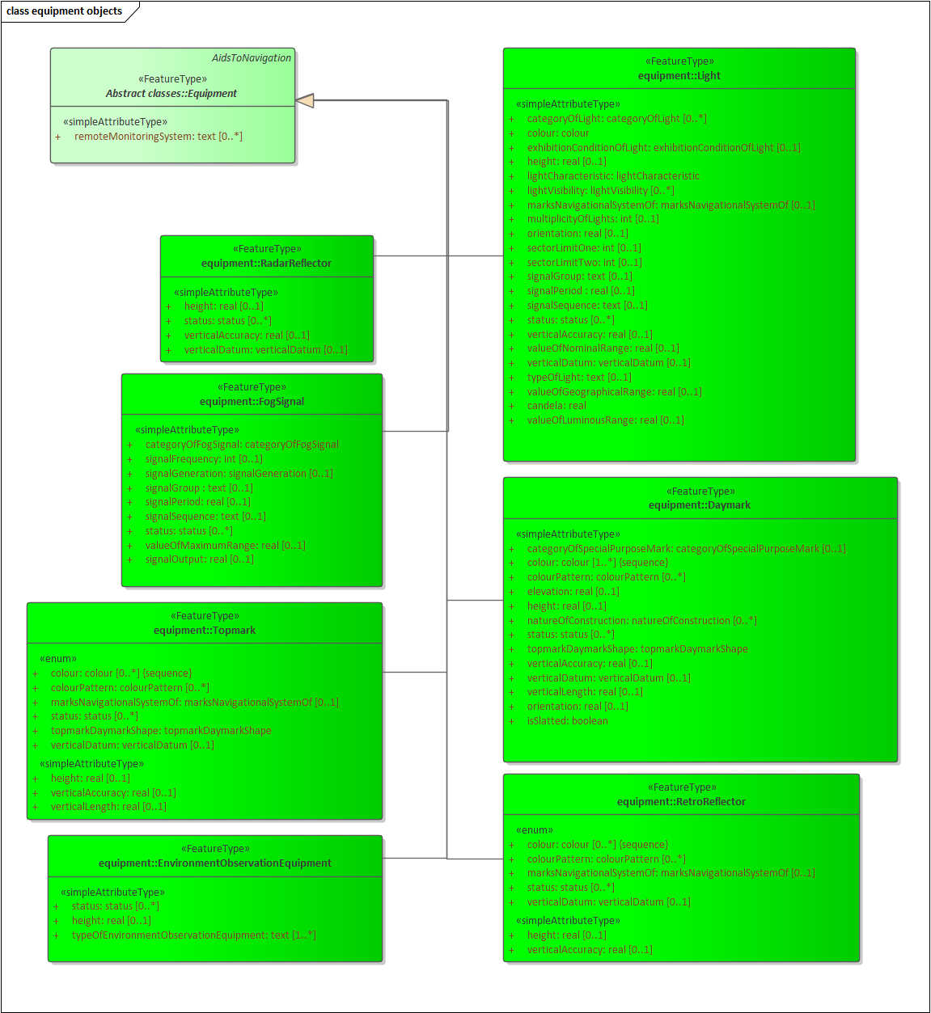
Figure 3. Equipment Feature types
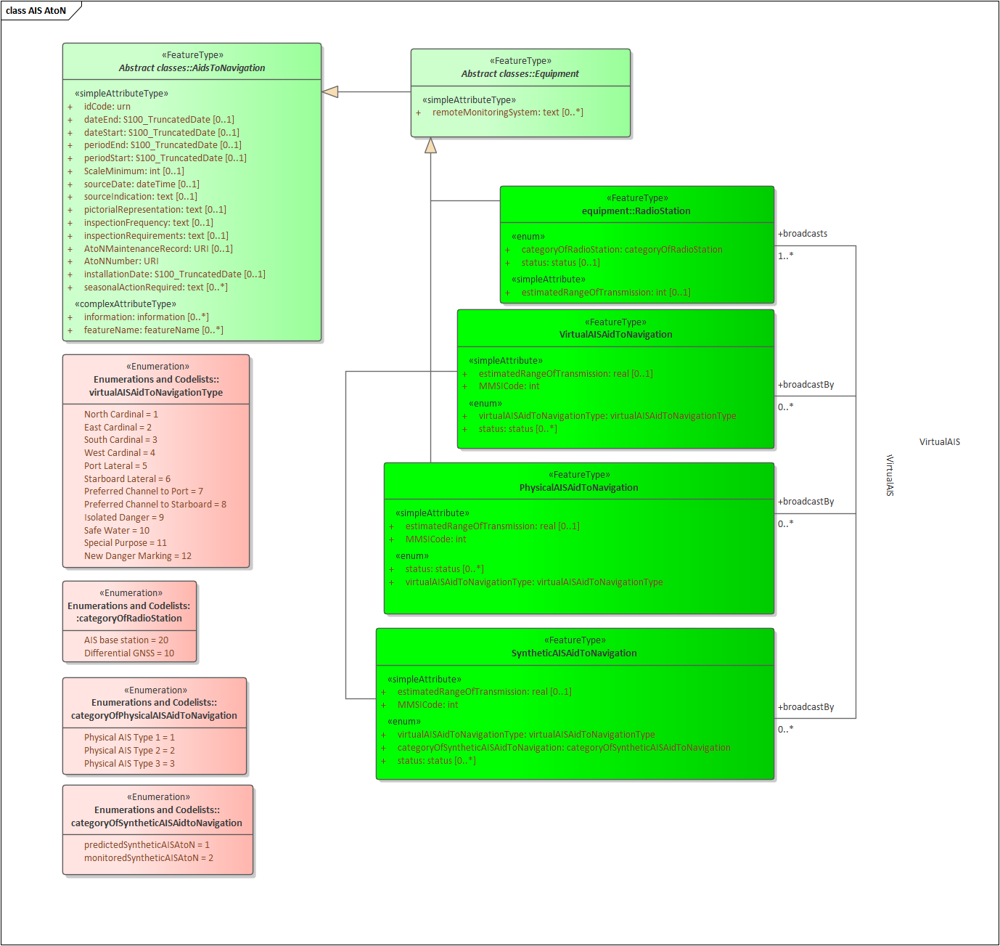
Figure 4. AIS Aids to Navigation
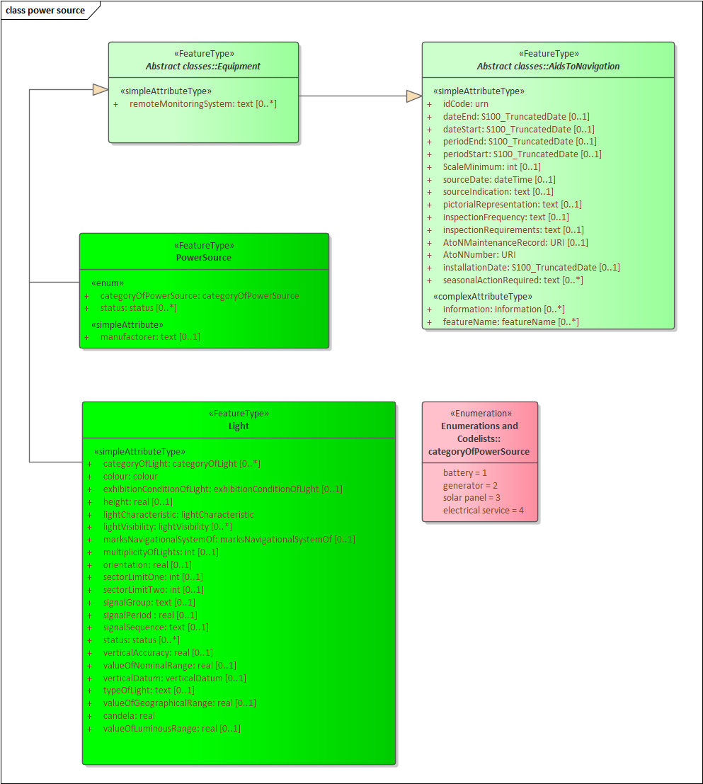
Figure 5. Power source
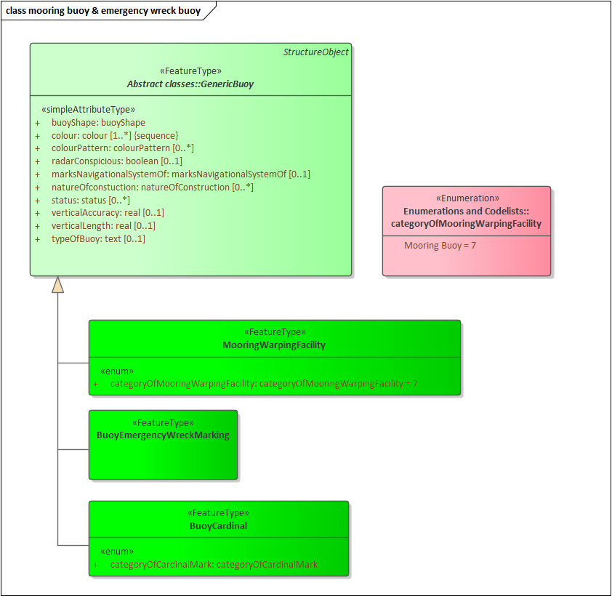
Figure 6. Mooring buoy & emergency wreck buoy
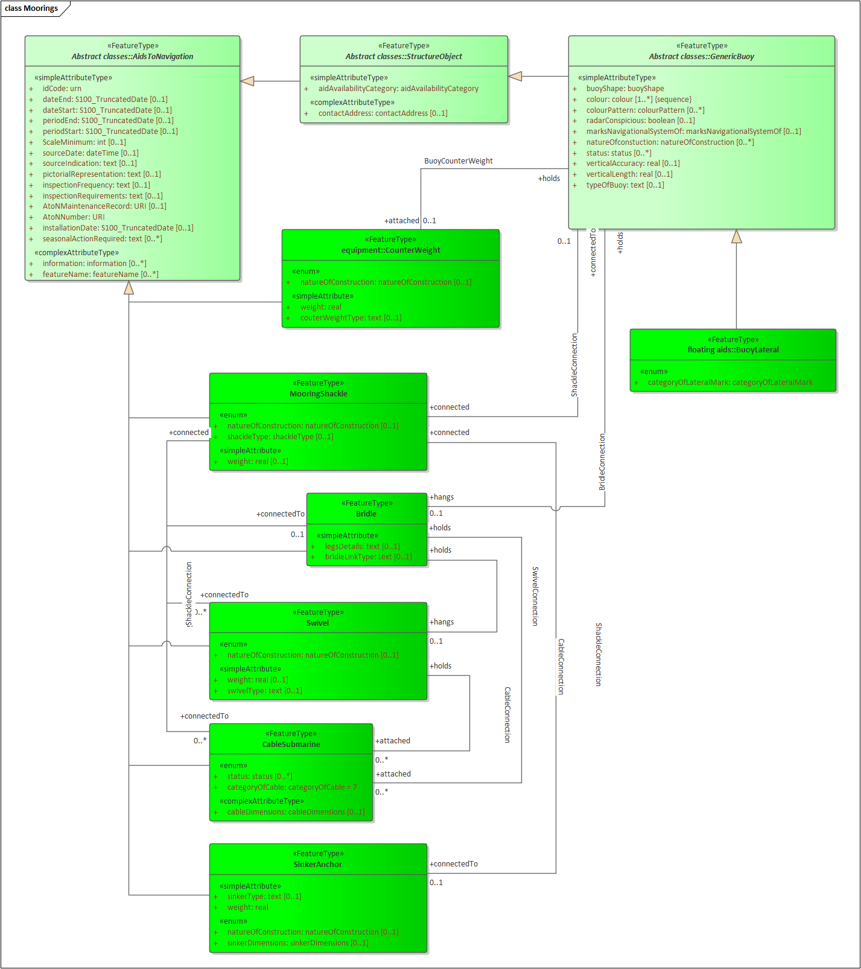
Figure 7. Moorings

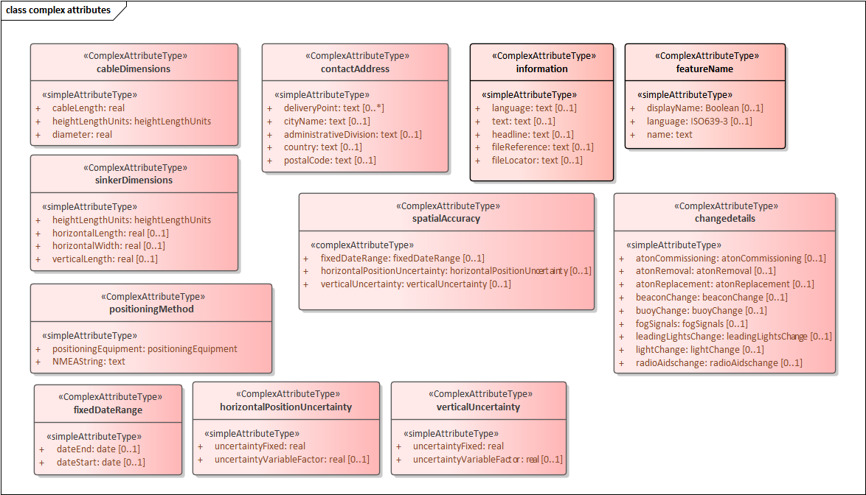
Figure 8. Complex attribute types

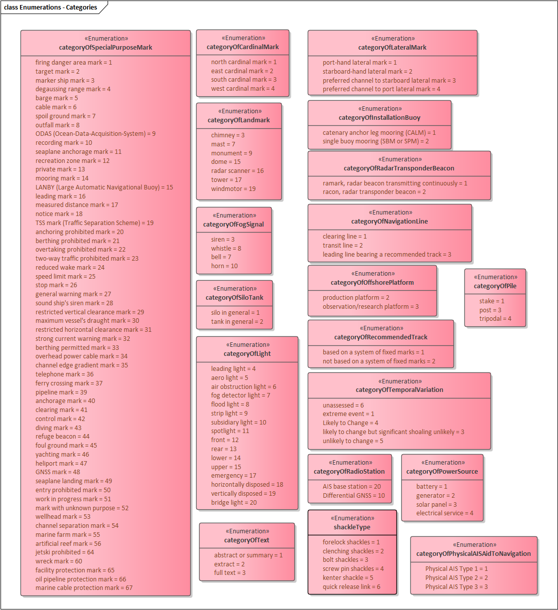
Figure 9. Enumerations – categories
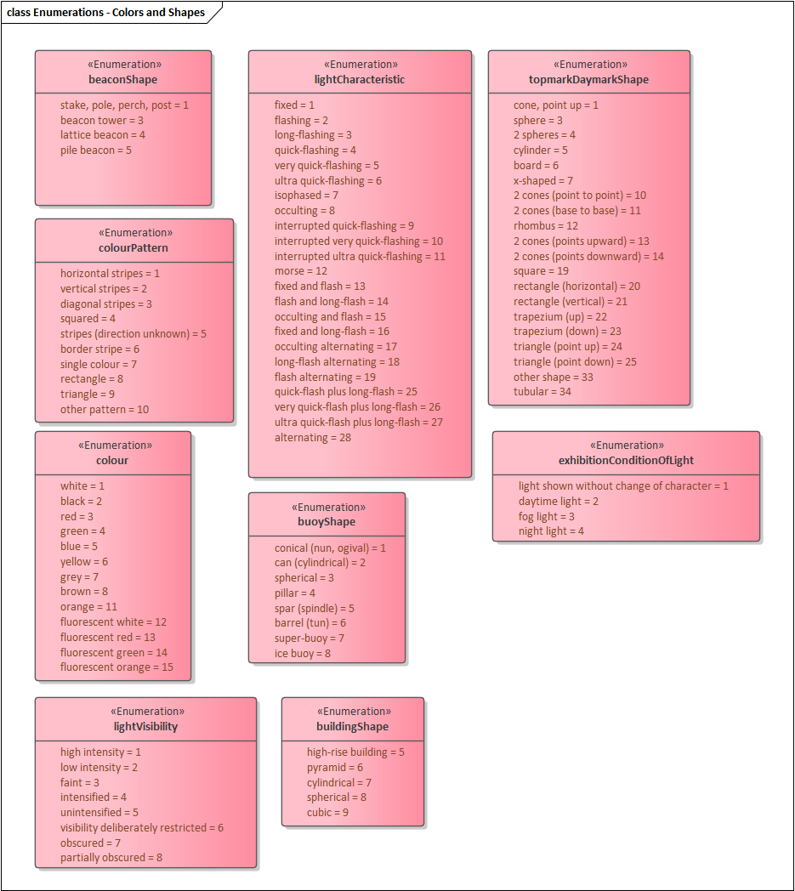
Figure 10. Enumerations – Colour, characteristics, and shape enumerated attributes

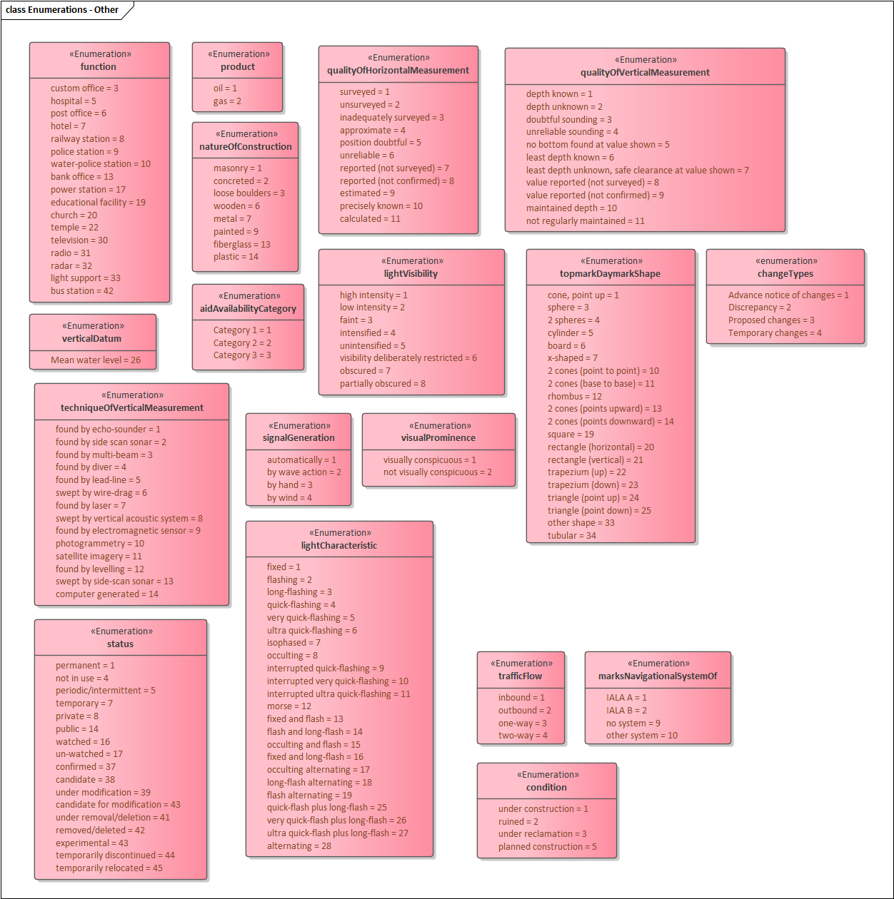
Figure 11. Enumerations - Other enumerated attributes
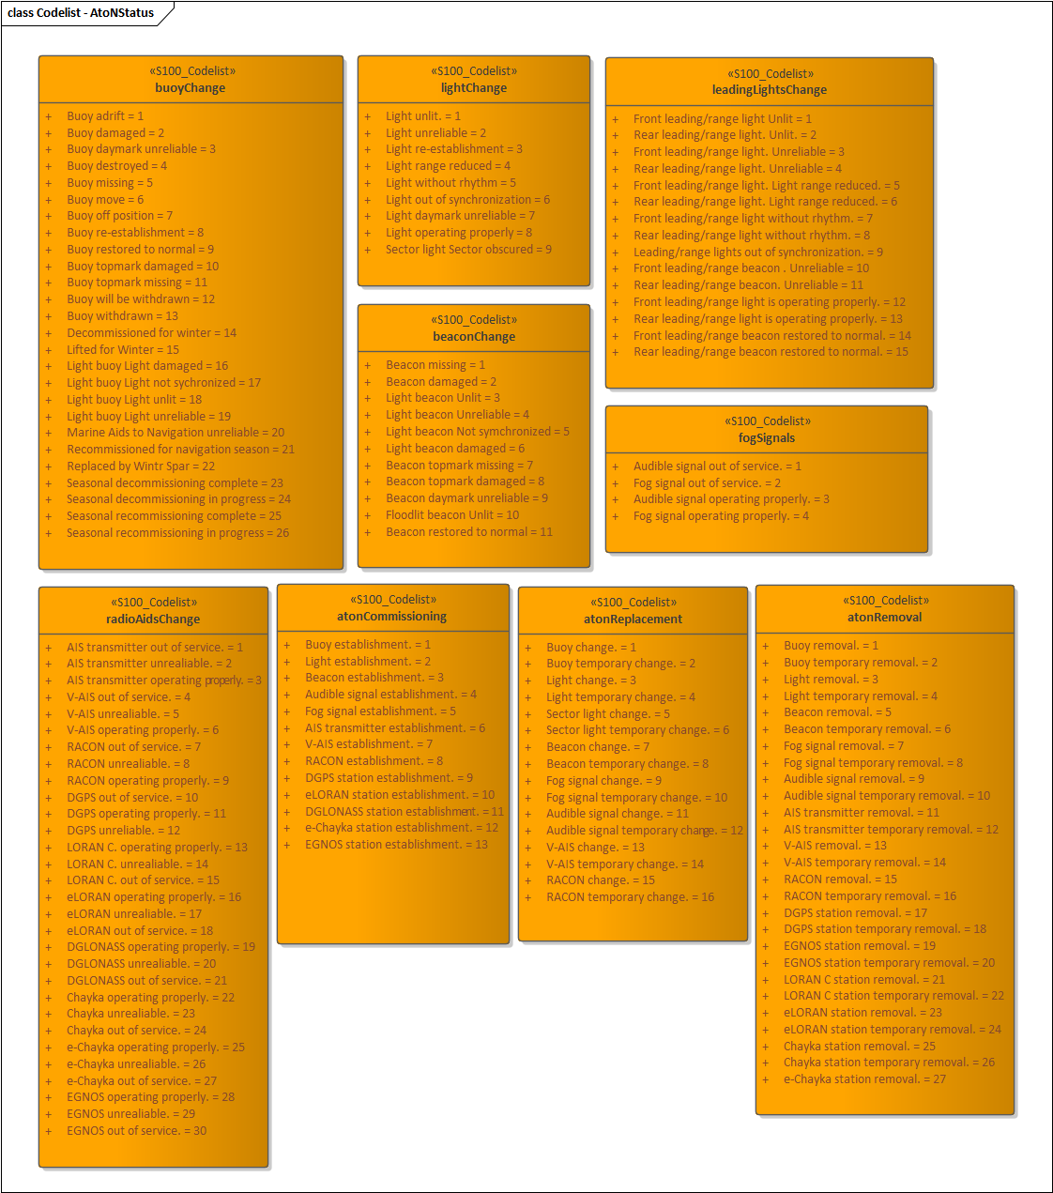
Figure 12. Codelist – AtoN Status

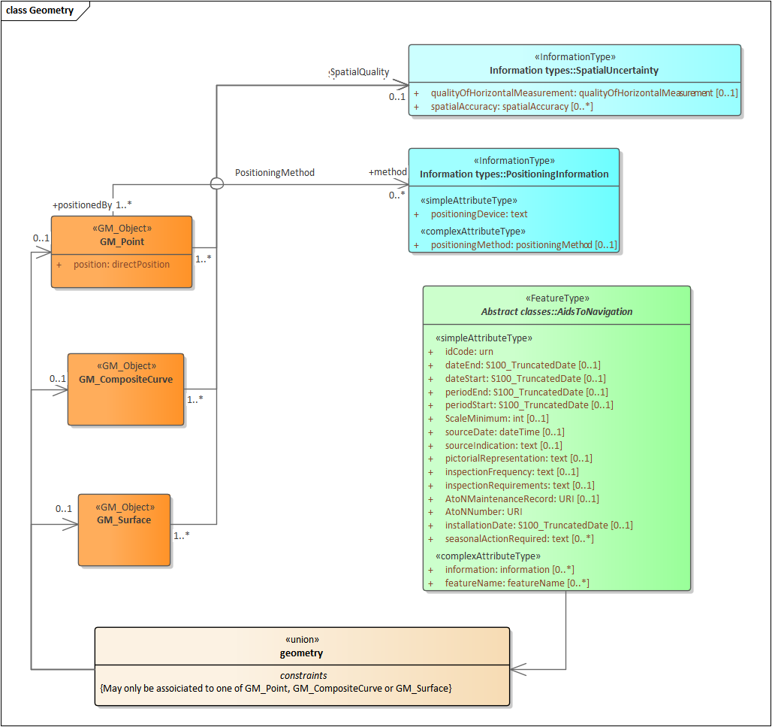
Figure 13. Spatial Attributes

Meta features application schema
Meta features include data coverage, data quality, datums and areas with established characteristics for navigational systems of marks (buoyage direction and system of marks). The application schema for meta features is depicted in Figure 12.

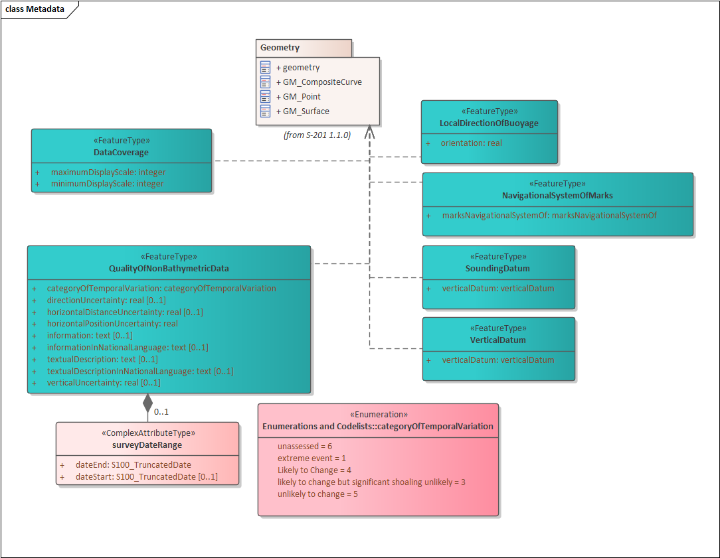
Figure 14. Meta features application schema

Feature Catalogue
The Feature Catalogue describes the feature types, information types, attributes, attribute values, associations and roles which may be used in the product. It also assigns the geometric primitives. The S-201 Feature Catalogue is available in an XML document which conforms to the S-100 XML Feature Catalogue Schema and can be downloaded from the IALA website (iala-aism.org). The feature catalogue is provided in Annex D.
Name: Aids to Navigation Feature Catalogue
Scope: Ocean, Coastal, Ports, Harbours and Inland waters
Version Number: 1.1.0
Version Date: 2022-10-27
Producer: IALA-AISM
10, rue des Gaudines
78100 Saint Germain en Laye, France
Telephone: +33 1 34 51 70 01, Fax: +33 1 34 51 82 05
URL : https://www.iala-aism.org
Language: English

Feature Types and Feature Instances
Features have two aspects – feature type and feature instance. A feature type is a class and is defined in a Feature Catalogue. Feature types contain descriptive attributes and do not contain any geometry (i.e. information about the shape and position of a real world entity). A feature instance is a single occurrence of the feature type and represented as an object in a dataset. A feature instance is located by a relationship to one or more spatial instances. A feature instance may exist without referencing a spatial instance.
S-201 makes use of the following feature types:
Geographic (Geo) feature type – carries the descriptive characteristics of a real world entity.
Relationship feature type – A feature relationship links instances of one feature type with instances of the same or a different feature type.
Meta features – Meta features contain information about other features within a dataset. Information defined by meta features overrides the default metadata values defined by the dataset descriptive records. Meta attribution on individual features overrides attribution on meta features.

Dataset
A dataset is a grouping of features, attributes, geometry and metadata which comprises a specific coverage. AtoN data is scale independent, but may use the scaleMinimum and scaleMaximum attributes of S100_GF_SpatialAttributeType to declutter the data in certain viewing scales. The use of scaleMinimum and scaleMaximum is at the discretion of the data producer.

Dataset rules
In order to facilitate the efficient processing and cataloguing of AtoN data the geographic coverage may be split into multiple datasets. There must be no overlapping datasets, except at the agreed adjoining national data limits, where, if it is difficult to achieve a perfect join, a 5 metre overlapping buffer zone may be used; and for this situation, there must be no gaps in data. The discovery metadata of a dataset must list all the Data Coverage features contained within that dataset.
Datasets are replaced by new editions that must be considered a whole replacement of the previous version. Delta change datasets are not permitted.
Datasets must not exceed 20MB.

Geometry
The specifications for S-201 geometry are the same as for S-101 geometry except that 3 dimensional geometry is not permitted even for sounding features since these features are not part of the S-201 application schema. The relevant (modified) extract from the S-101 product specification is reproduced below.
The underlying geometry of an S-201 dataset is constrained to level 3a which supports 0, 1 and 2 dimensional features (points, curves and surfaces) as defined by S-100 Part 7 – Spatial Schema.
Level 3a is described by the following constraints:
- Each curve must reference a start and end point (they may be the same).
- Curves must not self intersect.
- Areas are represented by a closed loop of curves beginning and ending at a common point.
- In the case of areas with holes, all internal boundaries must be completely contained within the external boundary and the internal boundaries must not intersect each other or the external boundary. Internal boundaries may touch other internal boundaries or the external boundary tangentially (i.e. at one point).
- The outer boundary of a surface must be in a clockwise direction (surface to the right of the curve) and the curve orientation positive. The inner boundary of a surface must be in a counter-clockwise direction (surface to the right of the curve) and the curve orientation negative.

S-201 further constrains Level 3a with the following:
- Coincident linear geometry must be avoided when there is a dependency between features.
- The interpolation of GM_CurveSegment must be loxodromic.
- Linear geometry is defined by curves which are made of curve segments. Each curve segment contains the geographic coordinates as control points and defines an interpolation method between them. The distance between two consecutive control points must not exceed 0.3 mm at a display scale of 1:10000.

The following exception applies to S-201:
- The use of coordinates is restricted to 2 dimensions.
- Soundings features which use GM_Point or GM_Multipoint with 3 dimensional coordinates are not currently included in S-201.

Coordinate Reference Systems (CRS)

Introduction
The single coordinate reference system is separated into the horizontal and vertical components.

Horizontal Geodetic Datum
WGS84 (World Geodetic System of 1984) must be used for the horizontal reference system for spatial data. WGS84 must be used as the reference ellipsoid.

Vertical Datum
Vertical datum shall be selected from the list in verticalDatum enumeration. If the local datum value is used, additional information must be provided using the comment attribute in the metadata, or information attribute on the feature instance. Positive value is above vertical datum and negative is below vertical datum.

Units of Measure
Units of measure for S-201 datasets must be as follows:

For height, depth and vertical length it must be metres.
For range it must be nautical miles.
For orientation it must be degrees.
For signal duration it must be seconds.
For audible signal output it must be decibel.
For signal frequency it must be Hertz.

Data Quality

Introduction
Data Quality is considered to be meta information and for S-201 it is divided into three parts:
- Data Compliance and integrity
- Positional accuracy
- lineage

Data Compliance and Integrity
S-201 datasets must be validated using the conformance checks that are listed in S-58. The data quality elements listed in S-100 Part 4C that are applicable to S-201 are indicated in the table of conformance checks listed in S-58.

Datasets must not be published unless they pass all the compliance checks designated as “Critical”.

The detailed results of applying compliance checks listed in S-58 are not required to be reported as part of the exchange set. They may be conveyed as support files or by separate arrangement.

Positional accuracy
S-201 positional accuracy data quality indicators do not use the model of data quality elements defined in S-100 Part 4c.

However, positional accuracy must be evaluated and must be indicated in dataset metadata or spatial attribute metadata as provided in the application schema (Figure 12). This specification does not prescribe a specific required level of positional accuracy.

Lineage
Lineage and process step information elements are not required to be present in S-201 datasets distributed to end user. They may be included as extra metadata in exchange sets distributed to vendors and distributors.

Required source information about S-201 datasets is limited to the source and distribution information contained in discovery metadata described in S-100 Part 4a and Section 12 of this product specification.

Data Capture and Classification
The Data Capture and Classification Guide (DCEG) is found in Annex A.

Data Maintenance

Introduction
Datasets are replaced by new editions that must be considered a whole replacement of the previous version. Delta change datasets are not permitted. Each edition of a dataset shall have an edition number that is greater than the previous version by one. First edition of a dataset shall have edition number set to 1.

When updating some of AtoNs inlucded in the dataset, changes of feature attributes and included source dates can be updated at the feature level, and re-issues without changing the edition number is allowed. Old dataset is replaced by re-issues in a whole replacement.

Maintenance and Update Frequency
Datasets are maintained as needed in accordance with data producer policy.

Portrayal
The Portrayal catalogue is found in Annex E.

Data Product format (encoding)

Introduction
The GML encoding of S-201 datasets is based on the S-100 profile of GML 3.2.1. This is described in S-100 Edition 5.0.0 Part 10b.

Detailed documentation of the S-201 encoding schema is provided in Annex B of this product specification.

Format Name: GML, Specification: S-100 profile of GML Part 10b.
File Structure: S-201 (IALA AToN Product Specification), Annex B.

Encoding of Latitude and Longitude
Values of latitude and longitude must be expressed with a precision of 7 decimal places. Coordinates must be encoded as decimals in the format described below. The encoding is indicated by multiplication factor fields defined in the dataset identification record by the S-100 GML schemas.

Encoding of coordinates as decimals
Values should be coded as decimal numbers with 7 or fewer digits after the decimal. The normative encoding is in degrees, with an accuracy of 10⁻⁷ degrees, i.e., 7 digits after the decimal point.
The decimal point must be indicated by the “.” character.
Trailing zeroes after the decimal point (and the decimal point itself if appropriate) may be omitted at producer discretion, but the accuracy must still be as indicated (e.g., 10⁻⁷ degrees for coordinates of default accuracy).
Latitude and longitude multiplication factors held in the Dataset Structure Information field under [coordMultFactorX] and [coordMultFactorY] must be set to a value corresponding to the encoding, e.g., {1} for coordinates encoded in decimal degrees.
Example: A longitude = 42.0000 is converted into X = longitude * coordMultFactorX = 42.0000 * 1 = 42.0000000.

Numeric Attribute Encoding
Floating point and integer attribute values must not contain leading zeros. Floating point attribute values must not contain non-significant trailing zeros.

Text Attribute Values
Character strings must be encoded using the character set defined in ISO 10646-1, in Unicode Transformation Format-8 (UTF-8).

Mandatory Attribute Values
There are four reasons why attribute values may be considered mandatory:
- They determine whether a feature is in the display base,
- Certain features make no logical sense without specific attributes,
- Some attributes are necessary to determine which symbol is to be displayed,
- Some attributes are required for safety of navigation.
All mandatory attributes are identified in the Feature Catalogue and summarised in Annex A – Data Classification and Encoding Guide.

Unknown Attribute Values
When a mandatory attribute code or tag is present but the attribute value is missing, it means that the producer wishes to indicate that this attribute value is unknown. Missing mandatory attributes must be “nilled” with a GML nilReason attribute giving the reason for omission.
Optional attributes must be omitted altogether if the value is unknown or missing. They must not be “nilled.”
Example: An isolated danger beacon feature has unknown color (mandatory attribute) and condition (optional attribute). The feature could be coded as:
<BeaconIsolatedDanger>
<beaconShape>beacon tower</beaconShape>
<colour nilReason=”unknown”/>
… other attributes…
… <condition> is NOT coded …
<BeaconIsolatedDanger>

Structure of dataset files
The order of data objects in each dataset file is described below:

Dataset identification information
Dataset structure information
Spatial records for by-reference geometries
Point
Multi point
Curve
Composite Curve
Surface
Information objects
Feature objects (Geometry may be encoded inline or by reference.)
Meta features
Geo features
S-201 Collection objects

Object identifiers
Features, information types, collection objects, meta features, and geometries (inline or by reference) are all required by the schema to have a gml:id attribute with a value that is unique within the dataset. The gml:id values must be used as the reference for the object from another object in the same dataset or another dataset.

All geographic feature classes in S-201 have the idCode attribute. This attribute shall be used to hold the Maritime Resource Name (MRN) identifier for the feature instance.

Dataset validation
Fields may be repeated or omitted as permitted by the XML schemas and the validation tests. Since XML schema cannot encode rules for conditional presence or attributes, these rules are checked by Schematron rules or other validation code.

Detailed documentation of schema
The detailed documentation of the S-100 Profile of GML Part 10b schema is in Annex B of this product specification.

Data coverage
All areas of a dataset must be covered by a DataCoverage meta feature.

Data overlap
S-201 datasets must not overlap other S-201 datasets, except as addressed in Clause 4.7.

Data quality
One or more QualityOfNonBathymetricData features must cover the dataset.

Data extent
Datasets must not cross the 180° meridian of longitude.

Data Product Delivery
This clause specifies the encoding and delivery mechanisms for an S-201 dataset. Data which conforms to this product specification must be delivered by means of an exchange set.

Name | ISO 19131 Elements | Value
Format name | DPS_DeliveryInformation.deliveryFormat > DPS_DeliveryFormat.formatName | GML*
Version | DPS_DeliveryInformation.deliveryFormat > DPS_DeliveryFormat.version | 3.2.1
Specification description | DPS_DeliveryInformation.deliveryFormat > DPS_DeliveryFormat.specification | GML*
Language | DPS_DeliveryInformation.deliveryFormat > DPS_DeliveryFormat.language | English
Character set | DPS_DeliveryInformation.deliveryFormat > DPS_DeliveryFormat.characterSet > MD_CharacterSetCode | 004 – utf8
Table 12.1 Data product delivery
* GML is an XML encoding for the transport and storage of geographic information, including both the geometry and the properties of geographic features, between distributed systems. The XML Schema for the GML application schema is provided in a schema document S201.xsd which imports other schema(s) defining common types. (All files are available on the S-100 distribution site https://github.com/IHO-S100WG ). Feature instances must validate against S201.xsd and conform to all other requirements specified in this data product specification including all constraints not captured in the XML Schema document.

Exchange set
S-201 datasets are grouped into exchange sets. Each exchange set consists of one or more AtoN datasets with an associated XML metadata file and a single Exchange Catalogue XML file containing metadata. It may also include one or more support files.

Units of Delivery: Exchange Set

Transfer Size: Unlimited

Medium Name: Digital data delivery

Other Delivery Information:

Each dataset must be contained in a physically separate, uniquely identified file on the transfer medium.
Each exchange set has a single exchange catalogue which contains the discovery metadata for each dataset and references to any support files.
Support files are supplementary information which are linked to the features and information types by attributes. The attributes containing these links are described in the application schema and feature catalogue.
An exchange set may be encapsulated into a form suitable for transmission by a mapping called a transmission encoding. An encoding translates each of the elements of the exchange set into a logical form suitable for writing to media and for transmission online. An encoding may also define other elements in addition to the exchange set contents (i.e., media identification, data extents etc…) and also may define commercial constructs such as encryption and compression methods.

If the data is transformed (e.g., for encryption or compression purposes) its content must not be changed. Digital signature and data security should be covered by a Memorandum of Understanding between involved parties.

This product specification does not define the transmission encoding which must be used as a default for transmission of data between parties.

The exchange set elements are as follows:

Mandatory Elements
- AtoN datasets – GML encoding of features/attributes and their associated geometry and metadata.
- Exchange Catalogue – the XML encoded representation of exchange set catalogue features [discovery metadata].

Optional Elements
- Supplementary files – These are contained within the exchange set as files and the map from the name included within the dataset and the physical location on the media is defined within the Exchange Catalogue.
- Feature Catalogue – If it is necessary to deliver the latest feature catalogue to the end user it may be done using the S-201 exchange set mechanism for datasets – i.e., include the updated feature catalogue in an exchange set.
- Portrayal Catalogue - If it is necessary to deliver the latest portrayal catalogue to the end user it may be done using the S-201 exchange set mechanism for datasets – i.e., include the updated feature catalogue in an exchange set.

Datasets
Datasets are distributed as files which are part of exchange sets structured as described in this specification. The distribution media are left to the discretion of the producer and distributor.
The following types of dataset files may be produced and contained within an exchange set:
- New dataset and new edition of a dataset (base dataset): Each new edition of a dataset must have the same name as the dataset that it replaces. A new edition can also be AtoN data that has previously been produced for this area. The encoding structure is located in Annex B.
- Cancellation: The dataset is cancelled and is deleted from the system. The structure for a cancellation is described in clause 11.5.

Dataset size
Datasets must not exceed 20 MB.

Dataset file naming
Dataset files shall be named

201CCCCXXXXXXXX.GML

The file name forms a unique identifier where:
- The first three characters are always “201” and identify the dataset as an S-201 dataset.
- CCCC – the next four characters identify the issuing agency by its alphanumeric agency code in the IHO producer code register in the IHO GI Registry (i.e., the IHO is identified as “AA”, not “1810”). Where the agency code consists of fewer than four characters, sufficient zeros must be suffixed to make the length exactly four characters (e.g., “AA00” for IHO).
- XXXXXXXX – the next eight characters may be used in any way by the producer to provide the unique file name. the length of this part is not limited.
- GML – the character sequence “GML” or “gml”.

Cancellations
In order to cancel a dataset, a cancellation dataset is created for which the edition number must be set to 0. Dataset edition number is a field in exchange set metadata, class S100_DatasetDiscoveryMetadata (Clause 12.2 Metadata classes). The cancellation dataset file may contain no data objects (features, information types, etc.) and any data objects present it in are ignored. The cancellation dataset may be part of an exchange set which contains other datasets, e.g., a new edition of a different dataset. This method is only used to cancel a dataset. Where a dataset is cancelled and its name is reused at a later date, the issue date must be greater than the issue date of the cancelled dataset. When the dataset is cancelled it is removed by the system.

Support Files
Dataset support files offer supplementary information that can be included in an ENC exchange set.
Text files must contain only general text as defined by this standard this product specification. (Extensible mark-up language (XML) supports UTF-8 character encoding). Text files may be (TXT), (XML) or (HTM) files. Text files should not reference picture files.
Support files may be in any of the support file formats defined in the S-100 enumeration S100_SupportFileFormat (defined in Part 4a-D-2.12) except that “Other” may not be used.

Support File Naming
All support files must have unique universal file identifiers. The file identifier of support information should not be used to describe the physical content of the file. The support file metadata that accompanies the file will inform the user of the name and purpose of the file (i.e. new, replacement and deletion).
In this encoding the support files are named according to the specifications given below:
201CCCCXXXXXXXX.EEE
The main part forms an identifier where:
- The first three characters are always “201” and identify the dataset as an S-210 dataset.
- CCCC – the next four characters identify the issuing agency by its alphanumeric agency code in the IHO producer code register in the IHO GI Registry (i.e., the IHO is identified as “AA”, not “1810”). Where the agency code consists of fewer than four characters, sufficient zeros must be suffixed to make the length exactly four characters (e.g., “AA00” for IHO).
- XXXXXXXX – the next eight characters can be used in any way by the producer, to provide the unique file name. It is not required to use all characters. the length of this part is not limited.
- .EEE – support file extension (Must conform to the file format.)

Support file management
When a support file is created or a subsequent version is issued it must carry its own issue date and be supported with a digital signature which authenticates it against the producer’s public key included in the exchange set metadata.

The type of support file is indicated in the “purpose” field of the discovery metadata. Support files carrying the “deletion” flag must be removed from the system. When a feature pointing to a text, picture or application file is deleted or updated so that it no longer references the file, the system software must check to see whether any other feature referenced the same file, before that file is deleted.

Each support file must be used only once in the exchange set.

Support files should be stored in a separate folder within the exchange set.

Exchange Catalogue
The exchange catalogue acts as the table of contents for the exchange set. The catalogue file of the exchange set must be named S201CATALOG.XML. No other file in the exchange set may be named S201CATALOG.XML. The contents of the exchange catalogue are described in Clause 12.
XML schemas for the exchange catalogue are located at http://registry.iho.int/

Metadata

Introduction
The metadata description is based on the S-100 metadata document section, which is a profile of the ISO 19115 standard. These documents provide a structure for describing digital geographic data and define metadata elements, a common set of metadata terminology, definitions and extension procedures.
The realization of exchange set classes, the exchange set catalogue, and the structure of exchange sets are the same as in S-100. The relevant UML diagrams from S-100 are therefore reproduced here for reference.

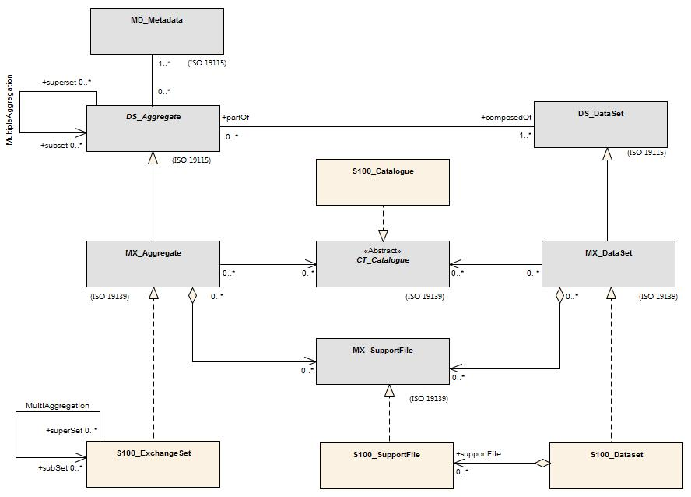
Figure 15. Realization of the Exchange Set Classes (from S-100)

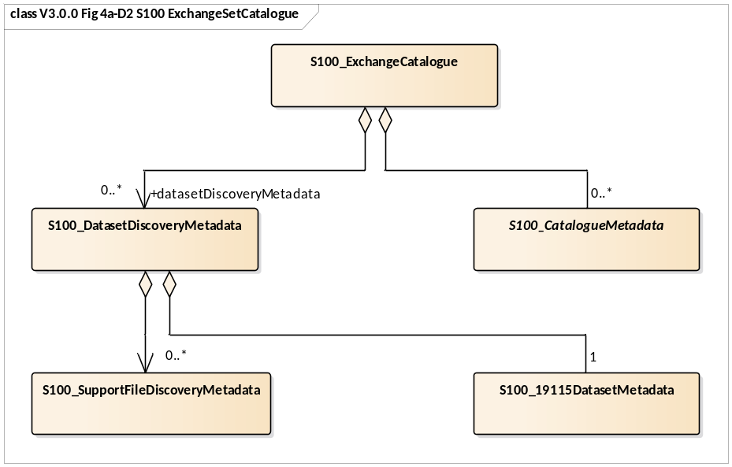
Figure 16. Exchange set catalogue and metadata (from S-100)
Since the class S100_DatasetDiscoveryMetadata aggregates ISO 19115 metadata (class S100_19115DatasetMetadata), metadata conforming to ISO 19115 is required to be included. Metadata for each support file is required if the exchange set contains support files.

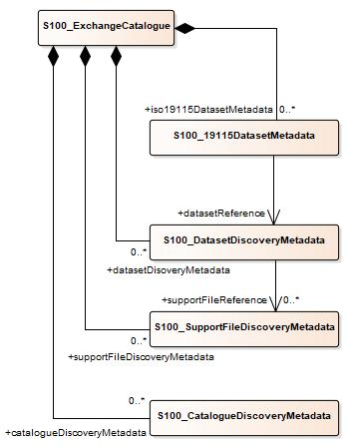
Figure 17. Exchange set including metadata (From S-100)

ISO 19115 metadata conforms to ISO 19115 with the additional constraints in S-100 Part 4A Appendix 4A-B.1 (Table B.1) which make the fileIdentifier element mandatory.

Metadata classes
Details for the S-100 metadata classes are depicted in the figure below.

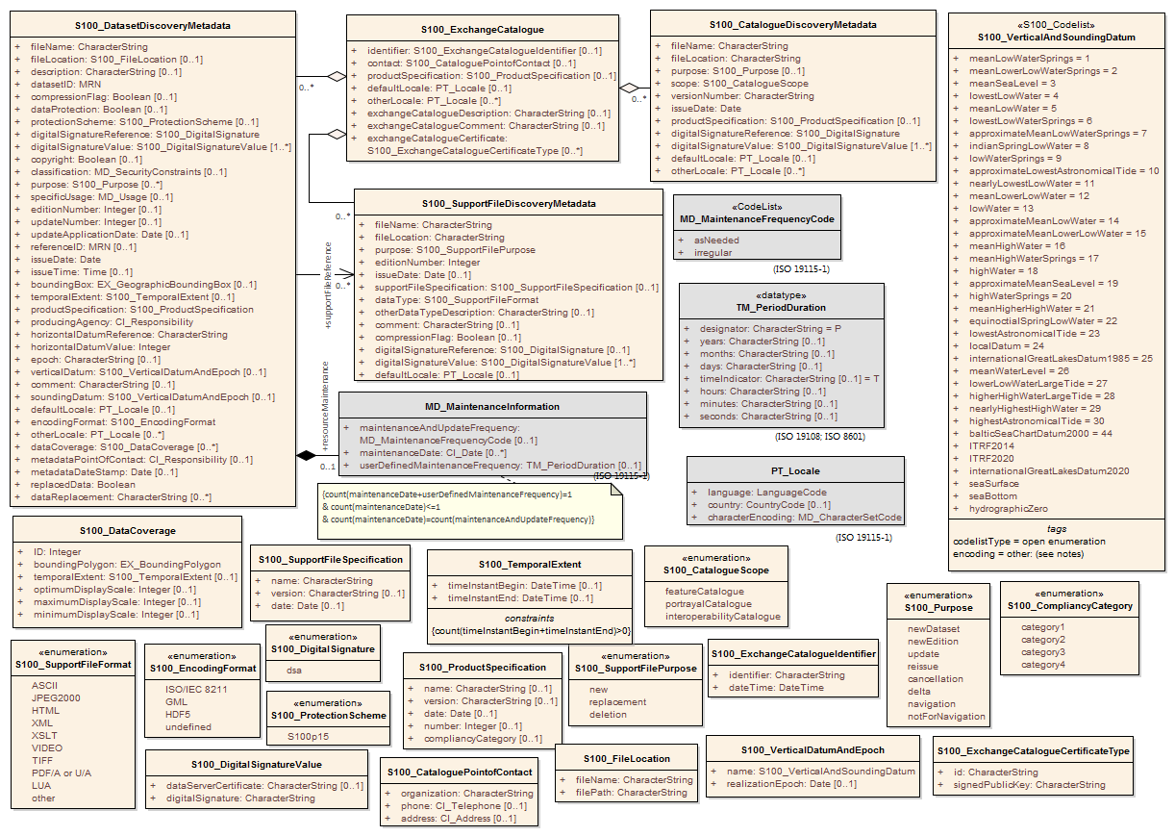
Figure 18. S-100 metadata class details

S100_ExchangeCatalogue

Each Exchange Set has a single S100_ExchangeCatalogue which contains meta information for the data and support files in the Exchange Set.
Role Name | Name | Description | Mult | Type | Remarks
Class | S100_ExchangeCatalogue | An Exchange Catalogue contains the discovery metadata about the exchange datasets and support files | - | - | -
Attribute | identifier | Uniquely identifies this Exchange Catalogue | 0..1 | S100_ExchangeCatalogueIdentifier
Attribute | contact | Details about the issuer of this Exchange Catalogue | 0..1 | S100_CataloguePointOfContact
Attribute | productSpecification | Details about the Product Specifications used for the datasets contained in the Exchange Catalogue | 0..* | S100_ProductSpecification
Attribute | defaultLocale | Default language and character set used for all metadata records in this Exchange Catalogue | 0..1 | PT_Locale | Default is English and UTF-8
Attribute | otherLocale | Other languages and character sets used for the localized metadata records in this Exchange Catalogue | 0..* | PT_Locale | Required if any localized entries are present in the Exchange Catalogue
Attribute | exchangeCatalogueDescription | Description of what the Exchange Catalogue contains | 0..1 | CharacterString
Attribute | exchangeCatalogueComment | Any additional Information | 0..1 | CharacterString
Attribute | certificates | Signed public key certificates referred to by digital signatures in the Exchange Set | 0..* | S100_SE_CertificateContainer | Content defined in S-100 Part 15. All certificates used, except the SA root certificate (installed separately by the implementing system) shall be included
Attribute | dataServerIdentifier | Identifies the data server for the permit | 0..1 | CharacterString
Role | datasetDiscoveryMetadata | Exchange Catalogues may include or reference discovery metadata for the datasets in the Exchange Set | 0..* | Aggregation S100_DatasetDiscoveryMetadata
Role | catalogueDiscoveryMetadata | Metadata for Catalogue | 0..* | Aggregation S100_CatalogueDiscoveryMetadata | Metadata for the Feature, Portrayal and Interoperability Catalogues, if any
Role | supportFileDiscoveryMetadata | Exchange Catalogues may include or reference discovery metadata for the support files in the Exchange Set | 0..* | Aggregation S100_SupportFileDiscoveryMetadata

S100_ExchangeCatalogueIdentifier
Role Name | Name | Description | Mult | Type | Remarks
Class | S100_ExchangeCatalogueIdentifier | An identifier for an Exchange Catalogue . | - | - | The concatenation of identifier, editionNumber and dateTime form the unique name
Attribute | identifier | Uniquely identifies this Exchange Catalogue | 1 | CharacterString | <S100XC:identifier>US_101_20200101_120101_01</S100XC:identifier>
Attribute | dateTime | Creation date and time of the Exchange Catalogue, including time zone | 1 | DateTime | Format: yyyymmddThhmmssZ

S100_CataloguePointofContact
Role Name | Name | Description | Mult | Type | Remarks
Class | S100_CataloguePointOfContact | Contact details of the issuer of this Exchange Catalogue | - | - | -
Attribute | organization | The organization distributing this Exchange Catalogue | 1 | CharacterString | This could be an individual producer, value added reseller, etc
Attribute | phone | The phone number of the organization | 0..1 | CI_Telephone
Attribute | address | The address of the organization | 0..1 | CI_Address

S100_DatasetDiscoveryMetadata
Role Name | Name | Description | Mult | Type | Remarks
Class | S100_DatasetDiscoveryMetadata | Metadata about the individual datasets in the Exchange Catalogue | - | - | -
Attribute | fileName | Dataset file name | 1 | CharacterString
Attribute | fileLocation | Relative location from the Exchange Set root directory | 1 | CharacterString | Path relative to the root directory of the Exchange Set. The location of the file after the Exchange Set is unpacked into a directory <ROOT> will be <ROOT>/S100_ROOT/<fileLocation>/<filename>
Attribute | description | Short description giving the area or location covered by the dataset | 0..1 | CharacterString | For example, a harbour or port name, between two named locations etc
Attribute | datasetID | Dataset ID expressed as a Marine Resource Name | 0..1 | URN | The URN must be an MRN
Attribute | compressionFlag | Indicates if the resource is compressed | 1 | Boolean | True indicates a compressed dataset resource  False indicates an uncompressed dataset resource
Attribute | dataProtection | Indicates if the data is encrypted | 1 | Boolean | True indicates an encrypted dataset resource  False indicates an unencrypted dataset resources
Attribute | protectionScheme | Specification of method used for data protection | 0..1 | S100_ProtectionScheme
Attribute | digitalSignatureReference | Specifies the algorithm used to compute digitalSignatureValue | 1 | S100_DigitalSignatureReference  (see Part 15)
Attribute | digitalSignatureValue | Value derived from the digital signature | 1..* | S100_DigitalSignatureValue  (see Part 15) | The value resulting from application of digitalSignatureReference  Implemented as the digital signature format specified in Part 15
Attribute | copyright | Indicates if the dataset is copyrighted | 1 | Boolean | True indicates the resource is copyrighted  False Indicates the resource is not copyrighted
Attribute | classification | Indicates the security classification of the dataset | 0..1 | Class MD_SecurityConstraints>MD_ClassificationCode (codelist) | 1. unclassified  2. restricted  3. confidential  4. secret  5. top secret  6. sensitive but unclassified  7. for official use only  8. protected  9. limited distribution
Attribute | purpose | The purpose for which the dataset has been issued | 0..1 | S100_Purpose
Attribute | notForNavigation | Indicates the dataset is not intended to be used for navigation | 1 | Boolean | True indicates the dataset is not intended to be used for navigation  False indicates the dataset is intended to be used for navigation
Attribute | specificUsage | The use for which the dataset is intended | 0..1 | MD_USAGE>specificUsage (character string)
Attribute | editionNumber | The Edition number of the dataset | 0..1 | Integer | When a data set is initially created, the Edition number 1 is assigned to it. The Edition number is increased by 1 at each new Edition. Edition number remains the same for a re-issue
Attribute | updateNumber | Update number assigned to the dataset and increased by one for each subsequent update | 0..1 | Integer | Update number 0 is assigned to a new dataset
Attribute | updateApplicationDate | This date is only used for the base cell files (that is new data set, re-issue and new edition), not update cell files. All updates dated on or before this date must have been applied by the producer | 0..1 | Date
Attribute | referenceID | Reference back to the datasetID | 0..1 | URN | Update metadata refers to the datasetID of the dataset metadata. This is used if and only if the dataset is an update  The URN must be an MRN
Attribute | issueDate | Date on which the data was made available by the Data Producer | 1 | Date
Attribute | issueTime | Time of day at which the data was made available by the Data Producer | 0..1 | Time | The S-100 datatype Time
Attribute | boundingBox | The extent of the dataset limits | 0..1 | EX_GeographicBoundingBox | -
Attribute | temporalExtent | Specification of the temporal extent of the dataset. | 0..1 | S100_TemporalExtent | The temporal extent is encoded as the date/time of the earliest and latest data records (in coverage datasets) or date/time ranges (in vector datasets)  If there is more than one feature in a dataset, the earliest and latest time values of records in all features are used, which means the earliest and latest values may be from different features  If date/time information for a feature is not encoded in the dataset, it is treated for the purposes of this attribute as extending indefinitely in the appropriate direction on the time axis, limited by the issue date/time or the cancellation or supersession of the dataset  This attribute is encoded if and only if at least one of the start and end of the temporal extent is known
Attribute | productSpecification | The Product Specification used to create this dataset | 1 | S100_ProductSpecification
Attribute | producingAgency | Agency responsible for producing the data | 1 | CI_Responsibility>CI_Organisation | See Table 17-3
Attribute | producerCode | The official IHO Producer Code from S-62 | 0..1 | CharacterString
Attribute | encodingFormat | The encoding format of the dataset | 1 | S100_EncodingFormat
Attribute | dataCoverage | Provides information about data coverages within the dataset | 0..* | S100_DataCoverage
Attribute | comment | Any additional information | 0..1 | CharacterString
Attribute | defaultLocale | Default language and character set used in the dataset | 0..1 | PT_Locale | In absence of defaultLocale the language is English, UTF-8
Attribute | otherLocale | Other languages and character sets used in the dataset | 0..* | PT_Locale
Attribute | metadataPointOfContact | Point of contact for metadata | 0..1 | CI_Responsibility>CI_Individual or  CI_Responsibility>CI_Organisation | Only if metadataPointOfContact is different to producingAgency
Attribute | metadataDateStamp | Date stamp for metadata | 0..1 | Date | May or may not be the issue date
Attribute | replacedData | If a data file is cancelled is it replaced by another data file | 0..1 | Boolean
Attribute | dataReplacement | Cell name | 0..* | CharacterString | A dataset may be replaced by 1 or more datasets
Attribute | navigationPurpose | Classification of intended navigation purpose (for Catalogue indexing purposes) | 0..3 | S100_NavigationPurpose | If Product Specification is intended for creation of navigational products this attribute should be mandatory
Role | resourceMaintenance | Information about the frequency of resource updates, and the scope of those updates | 0..1 | MD_MaintenanceInformation | S-100 restricts the multiplicity to 0..1 and adds specific restrictions on the ISO 19115 structure and content. See clause MD_MaintenanceInformation later in this Part  Format: PnYnMnDTnHnMnS (XML built-in type for ISO 8601 duration). See Notes

S100_NavigationPurpose
Role Name | Name | Description | Code | Remarks
Enumeration | S100_NavigationPurpose | The purpose of the dataset | -
Value | port | For port and near shore operations | 1 | -
Value | transit | For coast and planning purposes | 2 | -
Value | overview | For ocean crossing and planning purposes | 3 | -

S100_DataCoverage
Role Name | Name | Description | Mult | Type | Remarks
Class | S100_DataCoverage | A spatial extent where data is provided; and the display scale information for the provided data | - | - | This field is used by user systems as part of the data loading and unloading algorithms and it is strongly encouraged that Product Specifications mandate the use of one or more of the displayScale provided as part of S100_DataCoverage
Attribute | boundingPolygon | A polygon which defines the actual data limit | 1..1 | EX_BoundingPolygon
Attribute | temporalExtent | Specification of the temporal extent of the coverage | 0..1 | S100_TemporalExtent | The remarks for temporalExtent in the dataset discovery block (S100_DatasetDiscoveryMetadata) apply, except that their scope is the individual coverage and not the dataset as a whole
Attribute | optimumDisplayScale | The scale with which the data is optimally displayed | 0..1 | Integer | Example: A scale of 1:25000 is encoded as 25000
Attribute | maximumDisplayScale | The maximum scale with which the data is displayed | 0..1 | Integer
Attribute | minimumDisplayScale | The minimum scale with which the data is displayed | 0..1 | Integer
Attribute | approximateGridResolution | The resolution of gridded or georeferenced data (in metres) | 0..* | Real | A single value may be provided when all axes have a common resolution  For multiple value provision, use axis order as specified in dataset  May be approximate for ungeorectified data  For example, for 5 metre resolution, the value 5 must be encoded  * See note
NOTE: approximateGridResolution: If the grid cell size varies over the extent of the grid, an approximated value based on model parameters or production metadata should be used.

S100_Purpose
Role Name | Name | Description | Code | Remarks
Enumeration | S100_Purpose | The purpose of the dataset | -
Value | newDataset | Brand new dataset | 1 | No data has previously been produced for this area
Value | newEdition | New edition of the dataset or Catalogue | 2 | Includes new information which has not been previously distributed by updates
Value | update | Dataset update | 3 | Changing some information in an existing dataset
Value | reissue | Dataset that has been re-issued | 4 | Includes all the updates applied to the original dataset up to the date of the re-issue. A re-issue does not contain any new information additional to that previously issued by updates.
Value | cancellation | Dataset or Catalogue that has been cancelled | 5 | Indicates the dataset or Catalogue should no longer be used and can be deleted
Value | delta | Dataset difference | 6 | Reserved for future use

S100_TemporalExtent
Role Name | Name | Description | Mult | Type | Remarks
Class | S100_TemporalExtent | Temporal extent | -- |  | At least one of the timeInstantBegin and timeInstantEnd attributes must be populated; if both are known, both must be populated. The absence of either begin or end indicates indefinite validity in the corresponding direction, limited by the issue date/time or the cancellation or supersession of the dataset
Attribute | timeInstantBegin | The instant at which the temporal extent begins | 0..1 | DateTime
Attribute | timeInstantEnd | The instant at which the temporal extent ends | 0..1 | DateTime

S100_VerticalAndSoundingDatum
Role Name | Name | Description | Code | Remarks
S100_Codelist | S100_VerticalAndSoundingDatum | Allowable vertical and sounding datums | - | Open enumeration
Value | meanLowWaterSprings |  | 1 | (MLWS)
Value | meanLowerLowWaterSprings |  | 2 | -
Value | meanSeaLevel |  | 3 | (MSL)
Value | lowestLowWater |  | 4 | -
Value | meanLowWater |  | 5 | (MLW)
Value | lowestLowWaterSprings |  | 6 | -
Value | approximateMeanLowWaterSprings |  | 7 | -
Value | indianSpringLowWater |  | 8 | -
Value | lowWaterSprings |  | 9 | -
Value | approximateLowestAstronomicalTide |  | 10 | -
Value | nearlyLowestLowWater |  | 11 | -
Value | meanLowerLowWater |  | 12 | (MLLW)
Value | lowWater |  | 13 | (LW)
Value | approximateMeanLowWater |  | 14 | -
Value | approximateMeanLowerLowWater |  | 15 | -
Value | meanHighWater |  | 16 | (MHW)
Value | meanHighWaterSprings |  | 17 | (MHWS)
Value | highWater |  | 18 | (HW)
Value | approximateMeanSeaLevel |  | 19 | -
Value | highWaterSprings |  | 20 | -
Value | meanHigherHighWater |  | 21 | (MHHW)
Value | equinoctialSpringLowWater |  | 22 | -
Value | lowestAstronomicalTide |  | 23 | (LAT)
Value | localDatum |  | 24 | -
Value | internationalGreatLakesDatum1985 |  | 25 | -
Value | meanWaterLevel |  | 26 | -
Value | lowerLowWaterLargeTide |  | 27 | -
Value | higherHighWaterLargeTide |  | 28 | -
Value | nearlyHighestHighWater |  | 29 | -
Value | highestAstronomicalTide |  | 30 | (HAT)
Value | balticSeaChartDatum2000 | Baltic Sea Chart Datum 2000 | 44 | -
Value | internationalGreatLakesDatum2020 | International Great Lakes Datum 2020 | TBD | -
Value | seaSurface | Sea surface | TBD | Local sea bottom
Value | seaFloor | Sea bottom | TBD | Local sea bottom reference
Value | hydrographicZero | Hydrographic Zero | TBD | A vertical reference near the lowest astronomical tide (LAT, following IHO recommendation), below which the sea level falls only very exceptionally. The origin of the deviation between LAT and hydrographic zero may be due to a strong anticyclonic atmospheric condition, adding weight to the water column that may exceptionally cause the lowest sea level to fall below the astronomical low water level  The deviation between hydrographic zero and LAT must be less than 0.50 m

S100_EncodingFormat
Role Name | Name | Description | Code | Remarks
Enumeration | S100_DataFormat | The encoding format | - | -
Value | ISO/IEC 8211 | The ISO 8211 data format as defined in Part 10a | - | -
Value | GML | The GML data format as defined in Part 10b | - | -
Value | HDF5 | The HDF5 data format as defined in Part 10c |  | -
Value | undefined | The encoding is defined in the Product Specification | - | Use of Product Specification specific encoding means the data product and Product Specification is not intended for an IHO S-100 compliant system

S100_ProductSpecification
Role Name | Name | Description | Mult | Type | Remarks
Class | S100_ProductSpecification | The Product Specification contains the information needed to build the specified product | - | - | -
Attribute | name | The name of the Product Specification used to create the datasets | 0..1 | CharacterString | The name in the GI Registry should be used for this field.  For example, “Electronic Navigational Chart”
Attribute | version | The version number of the Product Specification | 0..1 | CharacterString | TR 2/2007 specifies versioning of Product Specifications.
Attribute | date | The version date of the Product Specification | 0..1 | Date
Attribute | productIdentifer | Machine readable unique identifier of a product type | 1 | CharacterString  (Restricted to Product ID values from the IHO Product Specification Register, in the IHO Geospatial Information Registry) | For example, “S-101”
Attribute | number | The number used to lookup the product in the Product Specification Register of the IHO GI registry | 1 | Integer | For IHO Product Specifications these should be taken from the IHO Product Specification Register in the IHO Geospatial Information (GI) Registry
Attribute | compliancyCategory | The level of compliance of the Product Specification to S-100 | 0..1 | S100_CompliancyCategory | See Part 4a, clause 4a-5.5

S100_CompliancyCategory
Role Name | Name | Description | Code | Remarks
Enumeration | S100_CompliancyCategory |  | - | -
Value | category1 | IHO S-100 object model compliant
Value | category2 | IHO S-100 compliant with non-standard encoding
Value | category3 | IHO S-100 compliant with standard encoding
Value | category4 | IHO S-100 and IMO harmonized display compliant

S100_ProtectionScheme
Role Name | Name | Description | Code | Remarks
Enumeration | S100_ProtectionScheme | Data protection schemes | - | -
Value | S100p15 | IHO S-100 Part 15 | - | See Part 15

S100_SupportFileDiscoveryMetadata
Role Name | Name | Description | Mult | Type | Remarks
Class | S100_SupportFileDiscoveryMetadata | Metadata about the individual support files in the Exchange Catalogue | - | - | -
Attribute | fileName | Name of the support file | 1 | CharacterString
Attribute | fileLocation | Full location from the Exchange Set root directory | 1 | CharacterString | Path relative to the root directory of the Exchange Set. The location of the file after the Exchange Set is unpacked into a directory <ROOT> will be <ROOT>/S100_ROOT/<fileLocation>/<filename>
Attribute | revisionStatus | The purpose for which the support file has been issued | 1 | S100_SupportFileRevisionStatus | For example new, replacement, etc
Attribute | editionNumber | The Edition number of the support file | 1 | Integer | When a data set is initially created, the Edition number 1 is assigned to it. The Edition number is increased by 1 at each new Edition. Edition number remains the same for a re-issue
Attribute | issueDate | Date on which the data was made available by the Data Producer | 0..1 | Date
Attribute | supportFileSpecification | The specification used to create this file | 0..1 | S100_SupportFileSpecification
Attribute | dataType | The format of the support file | 1 | S100_SupportFileFormat
Attribute | otherDataTypeDescription | Support file format other than those listed | 0..1 | CharacterString
Attribute | comment | Optional comment | 0..1 | CharacterString
Attribute | compressionFlag | Indicates if the resource is compressed | 1 | Boolean | True indicates a compressed resource  False indicates an uncompressed resource
Attribute | digitalSignatureReference | Specifies the algorithm used to compute digitalSignatureValue | 1 | S100_DigitalSignatureReference  (see Part 15)
Attribute | digitalSignatureValue | Value derived from the digital signature | 1..* | S100_DigitalSignatureValue  (see Part 15) | The value resulting from application of digitalSignatureReference  Implemented as the digital signature format specified in Part 15
Attribute | defaultLocale | Default language and character set used in the support file | 0..1 | PT_Locale | In absence of defaultLocale the language is English in UTF-8  A support file is expected to use only one as locale. Additional support files can be created for other locales
Attribute | supportedResource | Identifier of the resource supported by this support file | 0..* | CharacterString | Conventions for identifiers are still to be developed and will be defined later
Attribute | resourcePurpose | The purpose of the supporting resource | 0..1 | S100_ResourcePurpose | Identifies how the supporting resource is used

S100_SupportFileFormat
Role Name | Name | Description | Code | Remarks
Enumeration | S100_SupportFileFormat | The format used for the support file | - | -
Value | ASCII | UTF-8 text excluding control codes | 1 | -
Value | JPEG2000 | JPEG2000 format | 2 | ISO 15444
Value | HTML | Hypertext Markup Language | 3
Value | XML | Extensible Markup Language | 4
Value | XSLT | Extensible Stylesheet Language Transformations | 5
Value | VIDEO | Representation of moving images in unspecified format | 6
Value | TIFF | Tagged Image File Format | 7
Value | PDF/AorUA | Portable Document Format | 8 | ISO 19005, ISO 32000  Product Specification developers should take careful consideration in using PDF as a support file format. It is recommended that PDF never be used in products that will be used on a navigation system as it may impair night vision  Must be PDF/A or UA
Value | LUA | Lua programming language | 9
Value | other | Other format | 100

S100_SupportFileRevisionStatus
Role Name | Name | Description | Code | Remarks
Enumeration | S100_SupportFileRevisionStatus | The reason for inclusion of the support file in this Exchange Set | - | -
Value | new | A file which is new | 1 | Signifies a new file
Value | replacement | A file which replaces an existing file | 2 | Signifies a replacement for a file of the same name
Value | deletion | Deletes an existing file | 3 | Signifies deletion of a file of that name

S100_SupportFileSpecification
Role Name | Name | Description | Mult | Type | Remarks
Class | S100_SupportFileSpecification | The standard or specification to which a support file conforms | - | - | -
Attribute | name | The name of the specification used to create the support file | 1 | CharacterString
Attribute | version | The version number of the specification | 0..1 | CharacterString
Attribute | date | The version date of the specification | 0..1 | Date

S100_ResourcePurpose
Role Name | Name | Description | Code | Remarks
Enumeration | S100_ResourcePurpose | Defines the purpose of the supporting resource | - | -
Value | dataset | A dataset | 1
Value | featureCatalogue | A Feature Catalogue for an S-100 data product | 2
Value | portrayalCatalogue | A Portrayal Catalogue for an S-100 data product | 3
Value | interoperabilityCatalogue | An Interoperability Catalogue | 4
Value | supportFile | A support file | 5
Value | productVersion | All datasets conforming to a specific version of an S-100 Product Specification | 6
Value | productFamily | All datasets conforming to any active version of an S-100 Product Specification | 7
Value | software | Application software | 8
Value | system | Provides support or common information for a variety of applications and products | 9
Value | exchangeCatalogue | An Exchange Catalogue | 10
Value | ISO Metadata | Dataset metadata in ISO format | 11
Value | Language Pack | A Language pack | 12
Value | GML Schema | GML Application Schema | 13
Value | other | A type of resource not otherwise described | 100

S100_CatalogueDiscoveryMetadata
Role Name | Name | Description | Mult | Type | Remarks
Class | S100_CatalogueDiscoveryMetadata | Class for S-100 Catalogue metadata | - | - | -
Attribute | fileName | The name for the Catalogue | 1 | CharacterString
Attribute | fileLocation | Full location from the Exchange Set root directory | 1 | CharacterString | Path relative to the root directory of the Exchange Set. The location of the file after the Exchange Set is located in a directory <ROOT> will be <ROOT>/<fileLocation>/<fileName>
Attribute | purpose | The purpose for which the Catalogue has been issued | 0..1 | S100_Purpose  (codelist) | The values must be one of the following:  2 new edition  5 cancellation  Default is new edition
Attribute | editionNumber | The Edition number of the Catalogue | 1 | Integer | Initially set to 1 for a given productSpecification.number  Increased by 1 for each subsequent newEdition  Uniquely identifies the version of the Catalogue
Attribute | scope | Subject domain of the Catalogue | 1 | S100_CatalogueScope
Attribute | versionNumber | The version identifier of the Catalogue | 1 | CharacterString | Human readable version identifier
Attribute | issueDate | The issue date of the Catalogue | 1 | Date
Attribute | productSpecification | The Product Specification used to create this file | 1 | S100_ProductSpecification
Attribute | digitalSignatureReference | Specifies the algorithm used to compute digitalSignatureValue | 1 | S100_DigitalSignatureReference  (see Part 15)
Attribute | digitalSignatureValue | Value derived from the digital signature | 1..* | S100_DigitalSignatureValue  (see Part 15) | The value resulting from application of digitalSignatureReference  Implemented as the digital signature format specified in Part 15
Attribute | compressionFlag | Indicates if the resource is compressed | 1 | Boolean | True indicates a compressed resource  False indicates an uncompressed resource
Attribute | defaultLocale | Default language and character set used in the Catalogue | 0..1 | PT_Locale | In absence of defaultLocale the language is English in UTF-8
Attribute | otherLocale | Other languages and character sets used in the Catalogue | 0..* | PT_Locale

S100_CatalogueScope
Role Name | Name | Description | Code | Remarks
Enumeration | S100_CatalogueScope | The scope of the Catalogue | - | -
Value | featureCatalogue | S-100 Feature Catalogue | 1
Value | portrayalCatalogue | S-100 Portrayal Catalogue | 2
Value | interoperabilityCatalogue | S-100 Interoperability Catalogue | 3

MD_MaintenanceInformation
Role Name | Name | Description | Mult | Type | Remarks
Class | MD_MaintenanceInformation | Information about the scope and frequency of updating | - | - | S-100 restricts the ISO 19115-class to:  - prohibit maintenanceScope, maintenanceNote, and contact attributes;  - define restrictions on maintenanceAndUpdate‌Frequency, maintenanceDate, and userDefinedMaintenance‌Frequency attributes
Attribute | maintenanceAndUpdateFrequency | Frequency with which changes and additions are made to the resource after the initial resource is completed | 0..1 | MD_MaintenanceFrequencyCode (codelist) | Must be populated if userDefined‌MaintenanceFrequency is not present, otherwise optional. See Table MD_Maintenance‌Frequency‌Code in this Part for values allowed in S-100 metadata
Attribute | maintenanceDate | Date information associated with maintenance of the resource | 0..1 | CI_Date | Exactly one of maintenanceDate and userDefinedMaintenanceFrequency must be populated  Allowed value for dateType: nextUpdate
Attribute | userDefinedMaintenanceFrequency | Maintenance period other than those defined | 0..1 | TM_PeriodDuration | Exactly one of maintenanceDate and userDefinedMaintenanceFrequency must be populated  Only positive durations allowed

MD_MaintenanceFrequencyCode
Role Name | Name | Description | Code | Remarks
Enumeration | MD_MaintenanceFrequencyCode | Frequency with which modifications and deletions are made to the data after it is first produced | - | S-100 is restricted to only the following values from the ISO 19115-1 codelist. The conditions for the use of a particular value are described in its Remarks
Value | asNeeded | Resource is updated as deemed necessary | 1 | Use only for datasets which normally use a regular interval for update or supersession, but will have the next update issued at an interval different from the usual  Allowed if and only if userDefinedMaintenanceFrequency is not populated
Value | irregular | Resource is updated in intervals that are uneven in duration | 2 | Use only for datasets which do not use a regular schedule for update or supersession  Allowed if and only if userDefinedMaintenanceFrequency is not populated

CI_DateTypeCode
This codelist is documented in the ISO Schemas documentation, available in the S-100 Schemas distribution. It is used in several places in S-100 metadata.

PT_Locale
Role Name | Name | Description | Mult | Type | Remarks
Class | PT_Locale | Description of a locale | - | - | From ISO 19115-1
Attribute | language | Designation of the locale language | 1 | LanguageCode | ISO 639-2/T 3-letter language codes.
Attribute | country | Designation of the specific country of the locale language | 0..1 | CountryCode | ISO 3166-2 2-letter country codes
Attribute | characterEncoding | Designation of the character set to be used to encode the textual value of the locale | 1 | MD_CharacterSetCode | UTF-8 is used in S-100

